# Procedure for maintaining FEDEBOM Credentials

## Existing Credentials

### All credentials will be maintained in TOPUS

### All detailed procedures will be stored in one source of truth location

#### The Password Management Team Recommends

##### Let this team make the password updates

##### First Responder will facilitate the work sessions

##### Update the detailed procedures as changes are needed

##### When passwords are changed are needed, the process utilizes IT Connect Tickets

### TOPUS will notify stakeholders of password expirations based on requirements

### FEDEBOM Stakeholders will have access to [TOPUS reporting](https://it1.spt.ford.com/sites/OPSControlIDMaintenance/Public/SitePages/Home.aspx)

#### Stakeholders will be FEDEBOM team members

#### Convert TOPUS report to deck slide for weekly review.

## Obsolete Credentials

### LL6 approval process needs to include Ops Control

#### Process gap – Becky to follow-up with Rao

##### How can First Responders by notified

#### First Responders currently use IT Connect with approvals

### Ops Control Leadership approval

#### Credential is decommissioned with comments in TOPUS

#### Procedure detailing the process for updating password is archived

### Ops Control Leadership notifies new credential and procedure to Password Management

### Password Management archives data in TOPUS

## New Credentials

### LL6 approval process needs to include Ops Control

#### How can First Responders by notified

#### Can First Responders by part of the approval process

#### How will First Responders obtain new procedures

### Ops Control Leadership approval

#### New Credential

#### Procedure detailing the process for updating password

#### Current Password

### Ops Control Leadership provides new credential and procedure to Password Management

### Password Management enters data into TOPUS

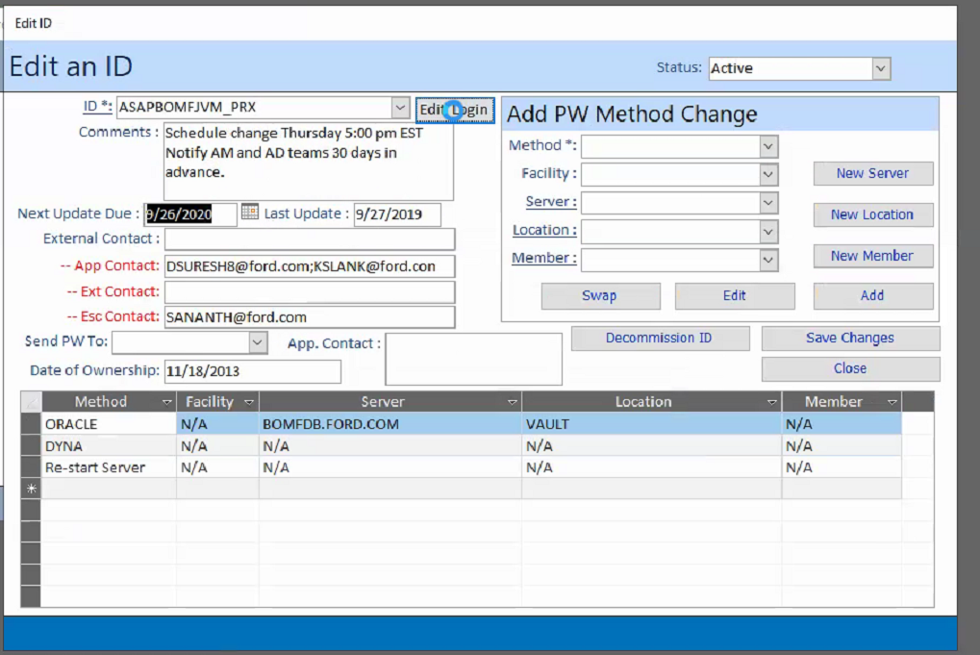

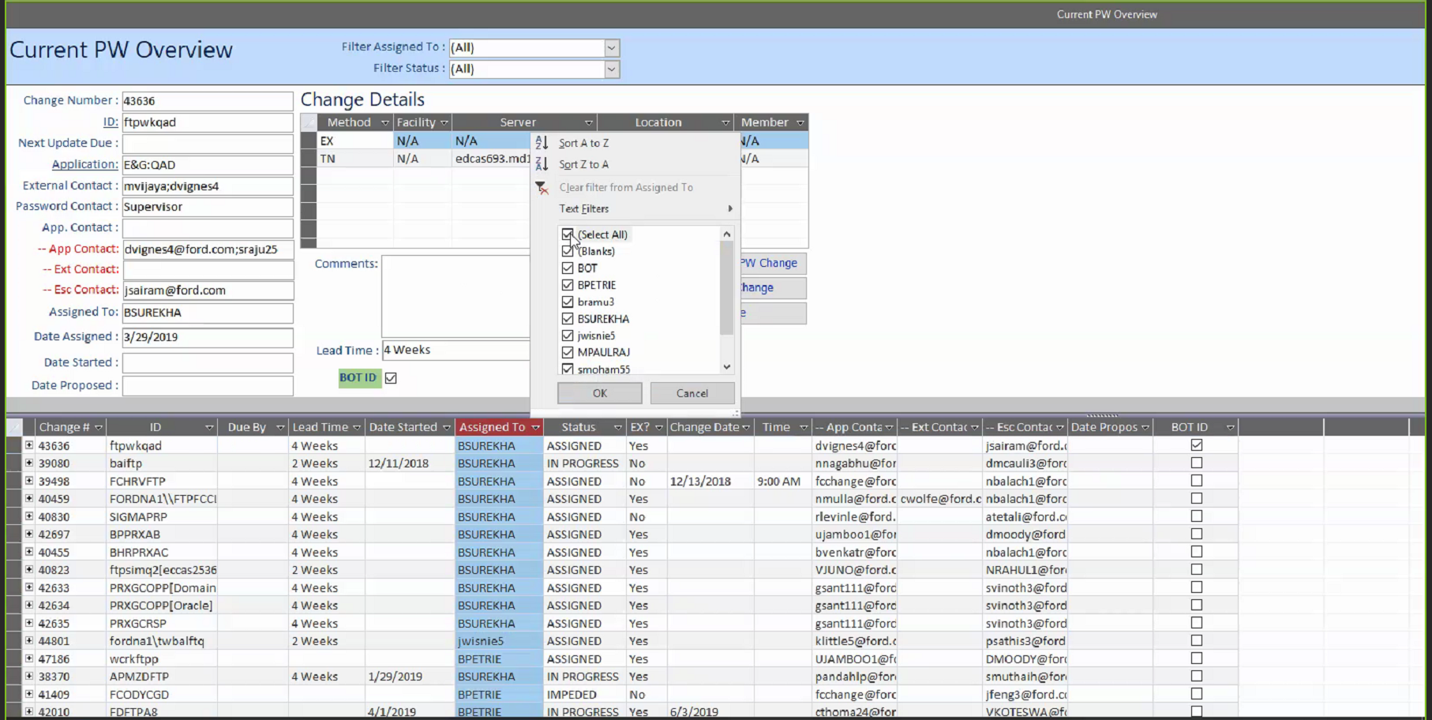

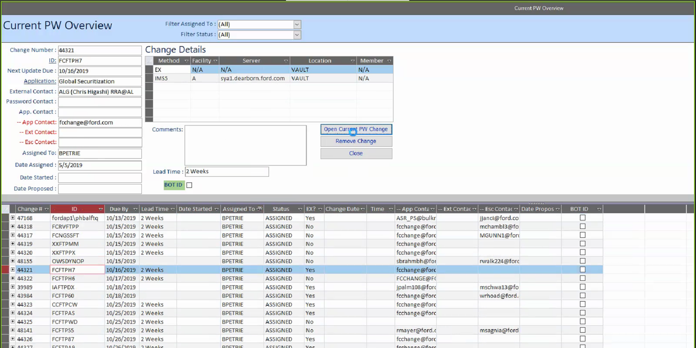

WHO creates the ticket